NIP Project — Movie Ticket Booking Submission
Pega Platform project · This document is your complete submission
Read this before you start:
1. Fill in Section 1 completely. The Pega application name must follow the format NIP-[Project]-[YourName].
2. Create a new Operator in Pega with your full name and log in as that operator before taking any screenshot.
3. When you create your test case, enter YOUR FULL NAME in the Issue Description (Vehicle) or Movie Name (Movie) field.
4. Complete only the section for your chosen project. Delete the other project section.
5. Paste one screenshot per user story (10 total). Follow the screenshot rules in your selected project section.
6. Answer every question in Sections 3 and 4 in your own words.
7. Save the file using this format: ProjectName_FirstName_LastName.docx. Use VehicleService or MovieTicket as the ProjectName. Examples: VehicleService_Ravi_Kumar.docx or MovieTicket_Ravi_Kumar.docx.

Section 1 — Your Details
Full Name | Abhishek Tiwari
Email ID (registered on NIP) | akhilbhai605@gmail.com
Phone Number | 9691966023
College Name | Amity University Madhya Pradesh
Course (e.g. IT, CS) | BTech CSE
State | Madhya Pradesh
Project Chosen (Vehicle Service OR Movie Ticket Booking) | Movie Ticket Booking
Pega Application Name (e.g. NIP-VehicleService-YourName) | NIP-MovieTicket-Abhishek Tiwari
Case Type Name (exact) | Movie Ticket Request
Pega Instance URL | https://09xoiqkh.pegacea.net/prweb/app/ticketing-booking/
Operator Name (created in Pega with your full name) | Abhishek Tiwari (Operator ID: Abhishek.Tiwari)

Section 2B — Movie Ticket Booking Management Application
Complete this section only if you selected this project. Delete the other project section before submitting.

Screenshot rules — IMPORTANT before you start:
1. Name your Pega application as: NIP-VehicleService-YourName OR NIP-MovieTicket-YourName
2. Create a new Operator in Pega with your full name (Security → Operators) and log in as that operator.
3. When you create your test case, enter YOUR FULL NAME in the Issue Description (Vehicle) or Movie Name (Movie) field.
4. The logged-in operator name must be visible in every screenshot wherever the Pega interface displays it.
5. The student's full name must be visible in all running-case screenshots.
6. Configuration screenshots must clearly show the relevant application or rule name.
Screenshots that do not show these will not be accepted.

US-001 — Submit Movie Ticket Request
What is expected:
Case created, customer submits Movie Name, Show Date, Show Time, Number of Tickets. Validation applied.
Screenshot — paste your screenshot below this line:
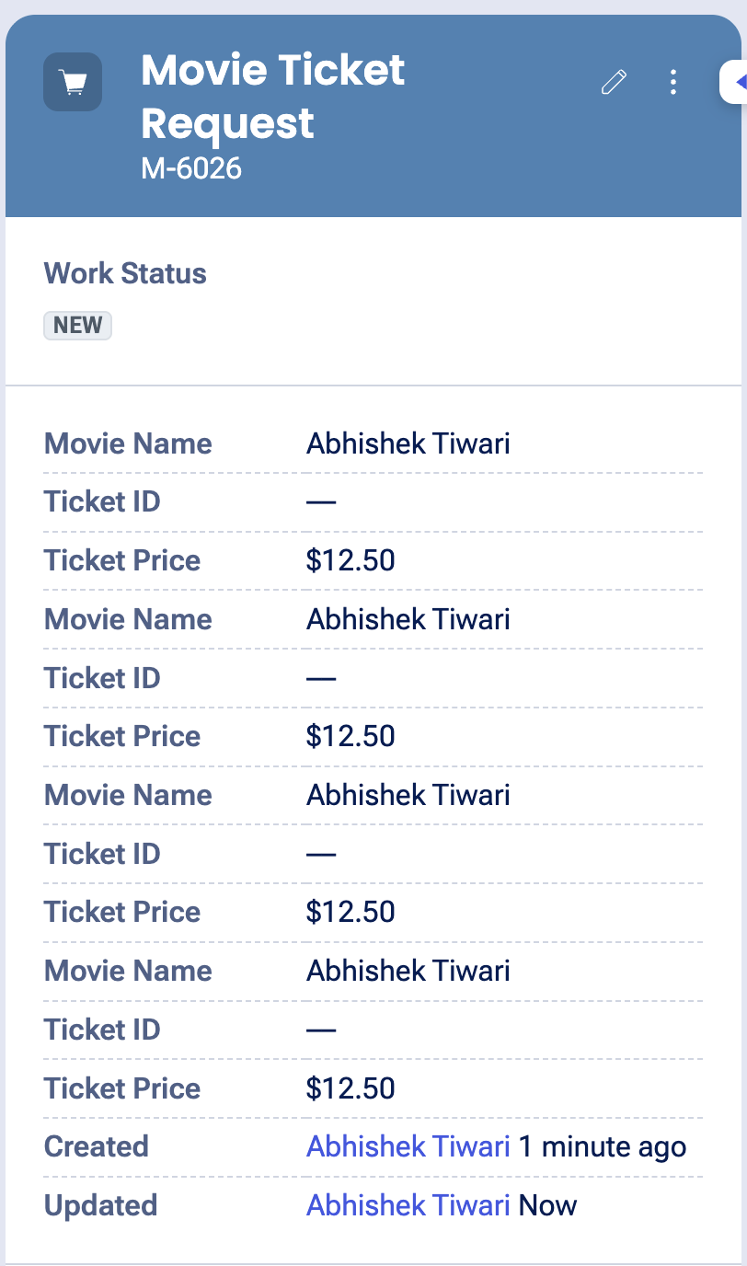
Screenshot 2026-08-30 at 15.04.11

What I built for this (1–2 lines in your own words):
Configured the Initial Request stage to capture Movie Name, Show Date, Show Time, and Number of Tickets with required-field validation. The test case uses my full name as the Movie Name.

US-002 — Check Show Availability
What is expected:
Availability stage. Seat Availability Status and Available Seats Count captured. Booking proceeds only if available.
Screenshot — paste your screenshot below this line:
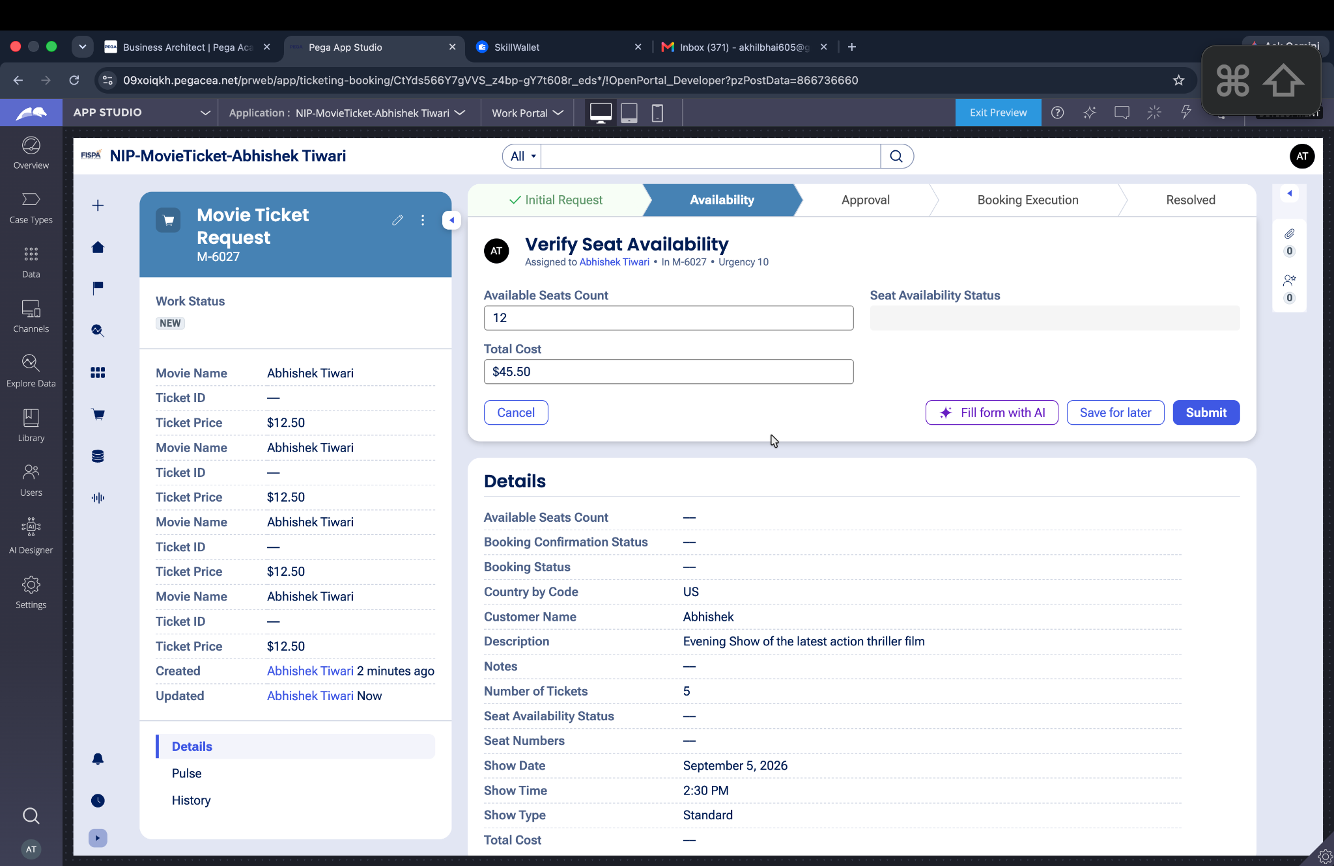
Screenshot 2026-08-30 at 16.16.47

What I built for this (1–2 lines in your own words):
Configured the Availability stage to capture the available seat count and keep availability information on the case before the booking proceeds.

US-003 — Calculate Booking Cost
What is expected:
Total Cost calculated automatically from Ticket Price and Number of Tickets using a business rule.
Screenshot — paste your screenshot below this line:
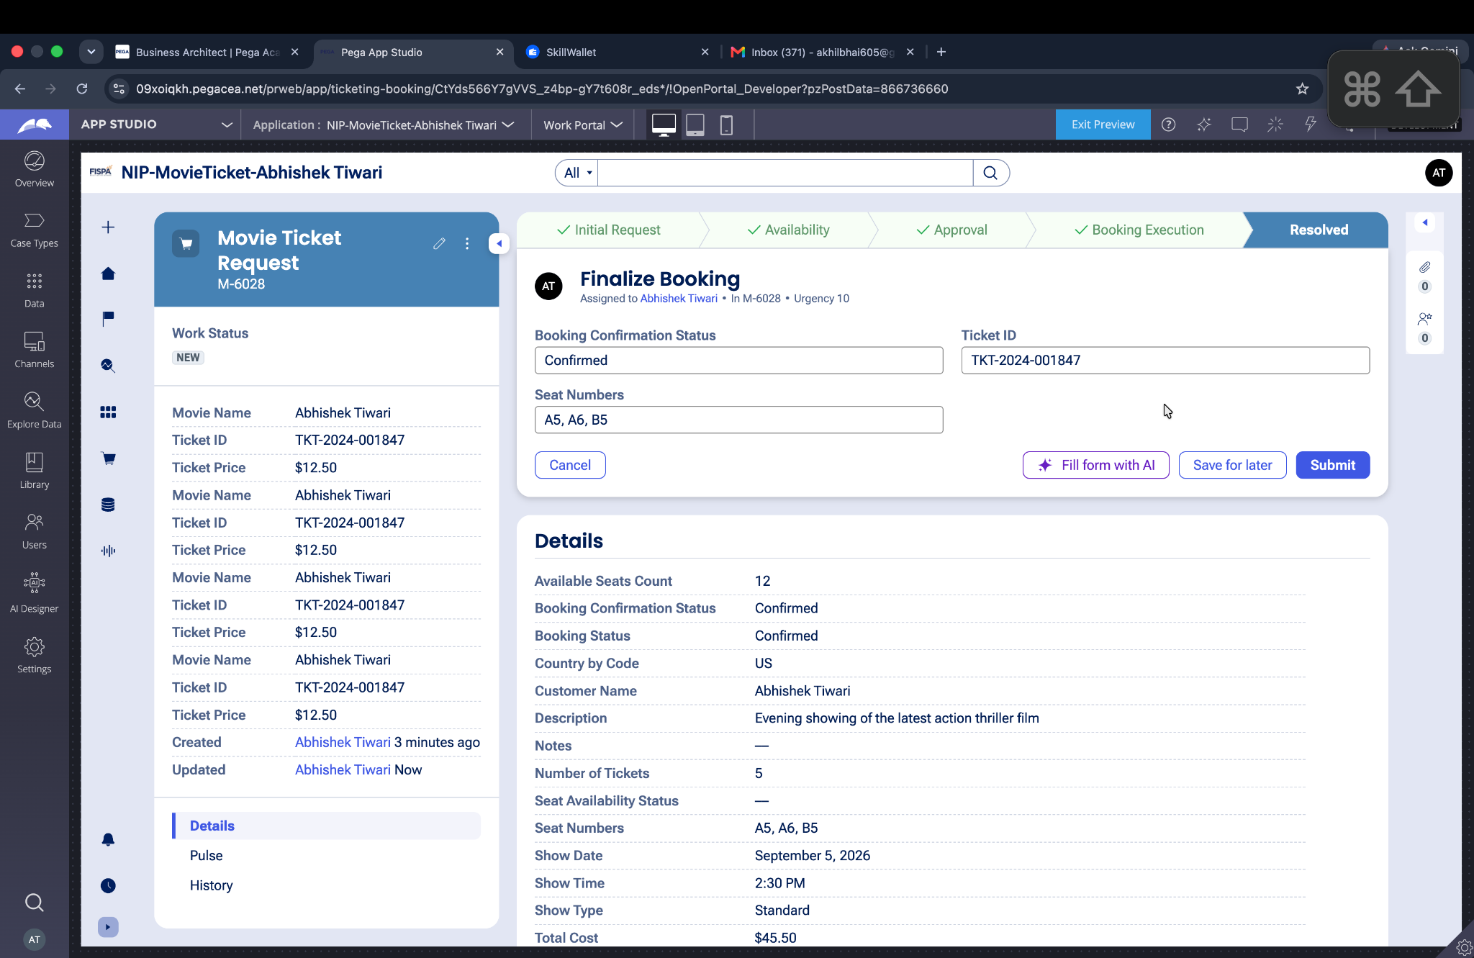
Screenshot 2026-08-30 at 16.23.46

What I built for this (1–2 lines in your own words):
Configured the calculated Total Cost using Ticket Price and Number of Tickets so the booking price is updated automatically.

US-004 — Confirm Booking Request
What is expected:
Approval stage assigned to Customer. Booking Status captured. Flow branches on confirm/cancel.
Screenshot — paste your screenshot below this line:
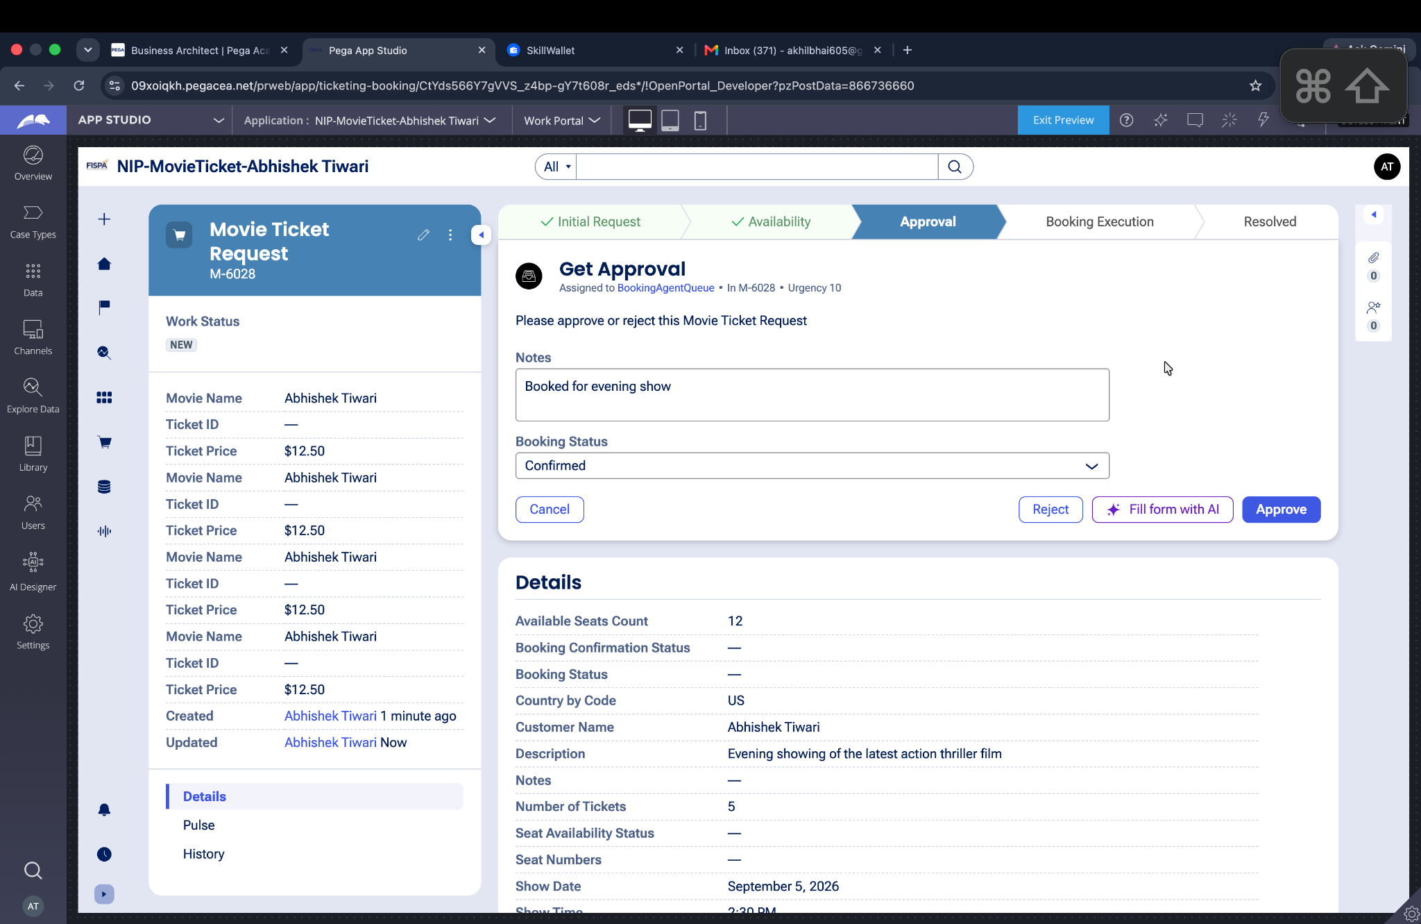
Screenshot 2026-08-30 at 16.22.19

What I built for this (1–2 lines in your own words):
Configured the Approval stage to let the customer confirm the booking through the Booking Status decision and continue the confirmed path.

US-005 — Maintain Movie and Show Data
What is expected:
Reusable Movie and Show data objects created with Movie Name, Genre, Show Date, Show Time, Seat Capacity — linked to case.
Screenshot — paste your screenshot below this line:
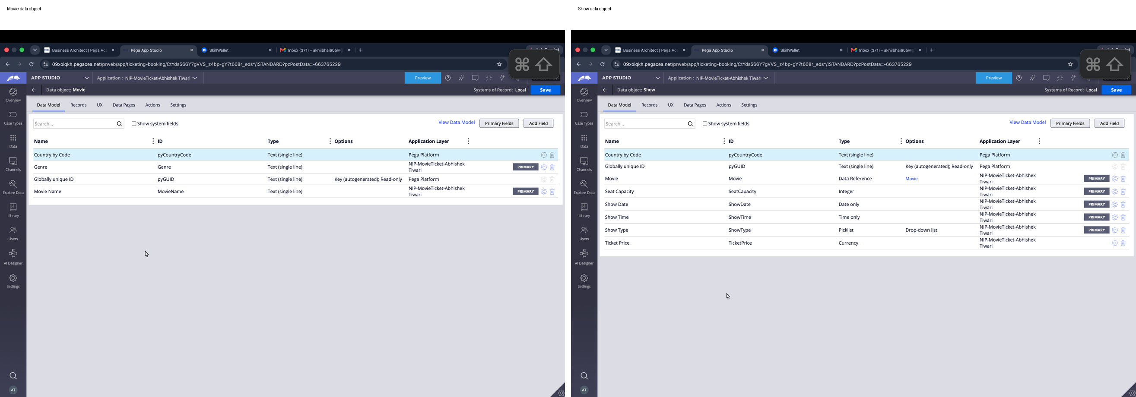

What I built for this (1–2 lines in your own words):
Created reusable Movie and Show data objects and associated the movie/show details with the Movie Ticket Request case.

US-006 — Review Booking Details
What is expected:
Confirmation screen shows Movie Name, Show Timing, Number of Tickets and Total Cost clearly.
Screenshot — paste your screenshot below this line:
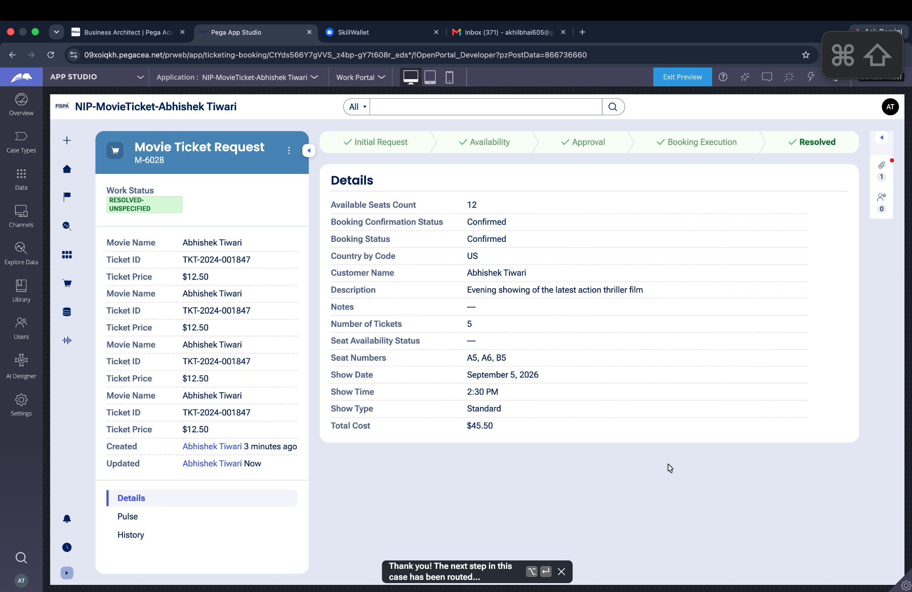
Screenshot 2026-08-30 at 16.24.24

What I built for this (1–2 lines in your own words):
Configured the confirmation/finalization view so the customer-facing case details show the movie, show timing, ticket quantity, and total cost before completion.

US-007 — Process Ticket Booking
What is expected:
Booking Execution stage. Seat Numbers, Ticket ID and Booking Confirmation Status maintained.
Screenshot — paste your screenshot below this line:
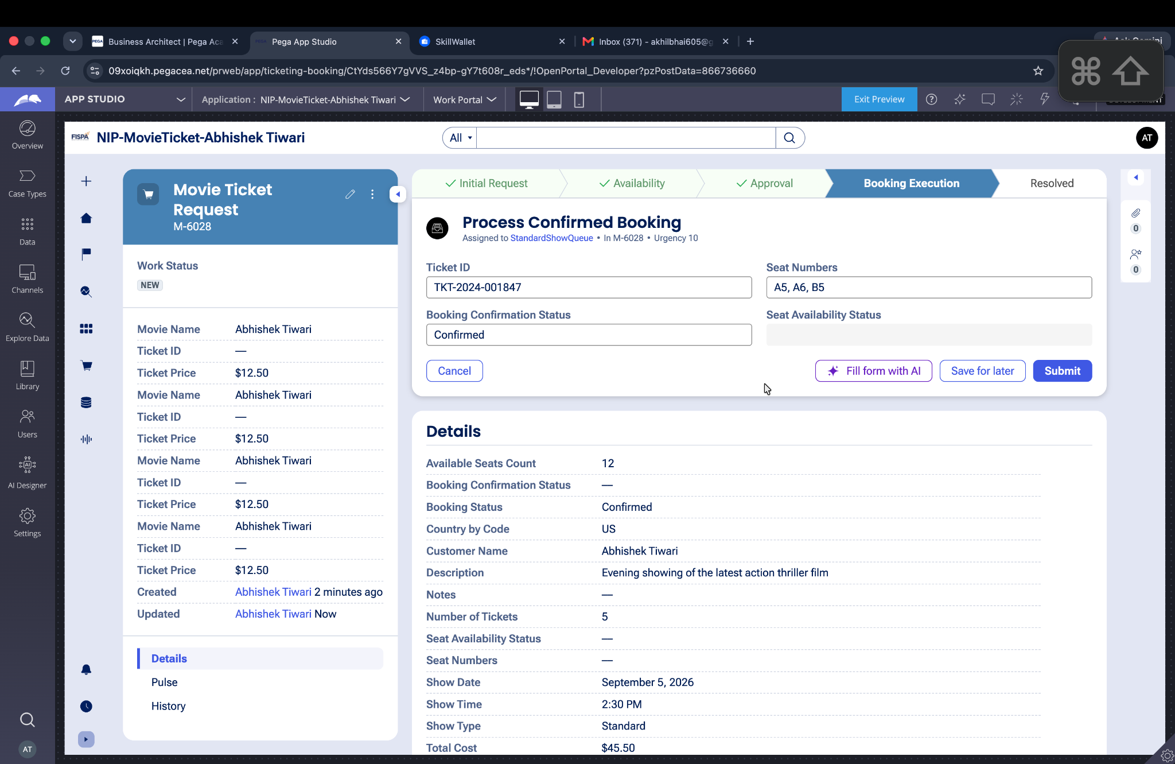
Screenshot 2026-08-30 at 16.23.02

What I built for this (1–2 lines in your own words):
Added the Booking Execution stage to maintain Ticket ID, Seat Numbers, and Booking Confirmation Status for the completed booking.

US-008 — Notify Booking Confirmation
What is expected:
Correspondence rule triggered on case resolution. Email includes movie, show, seat and cost details.
Screenshot — paste your screenshot below this line:
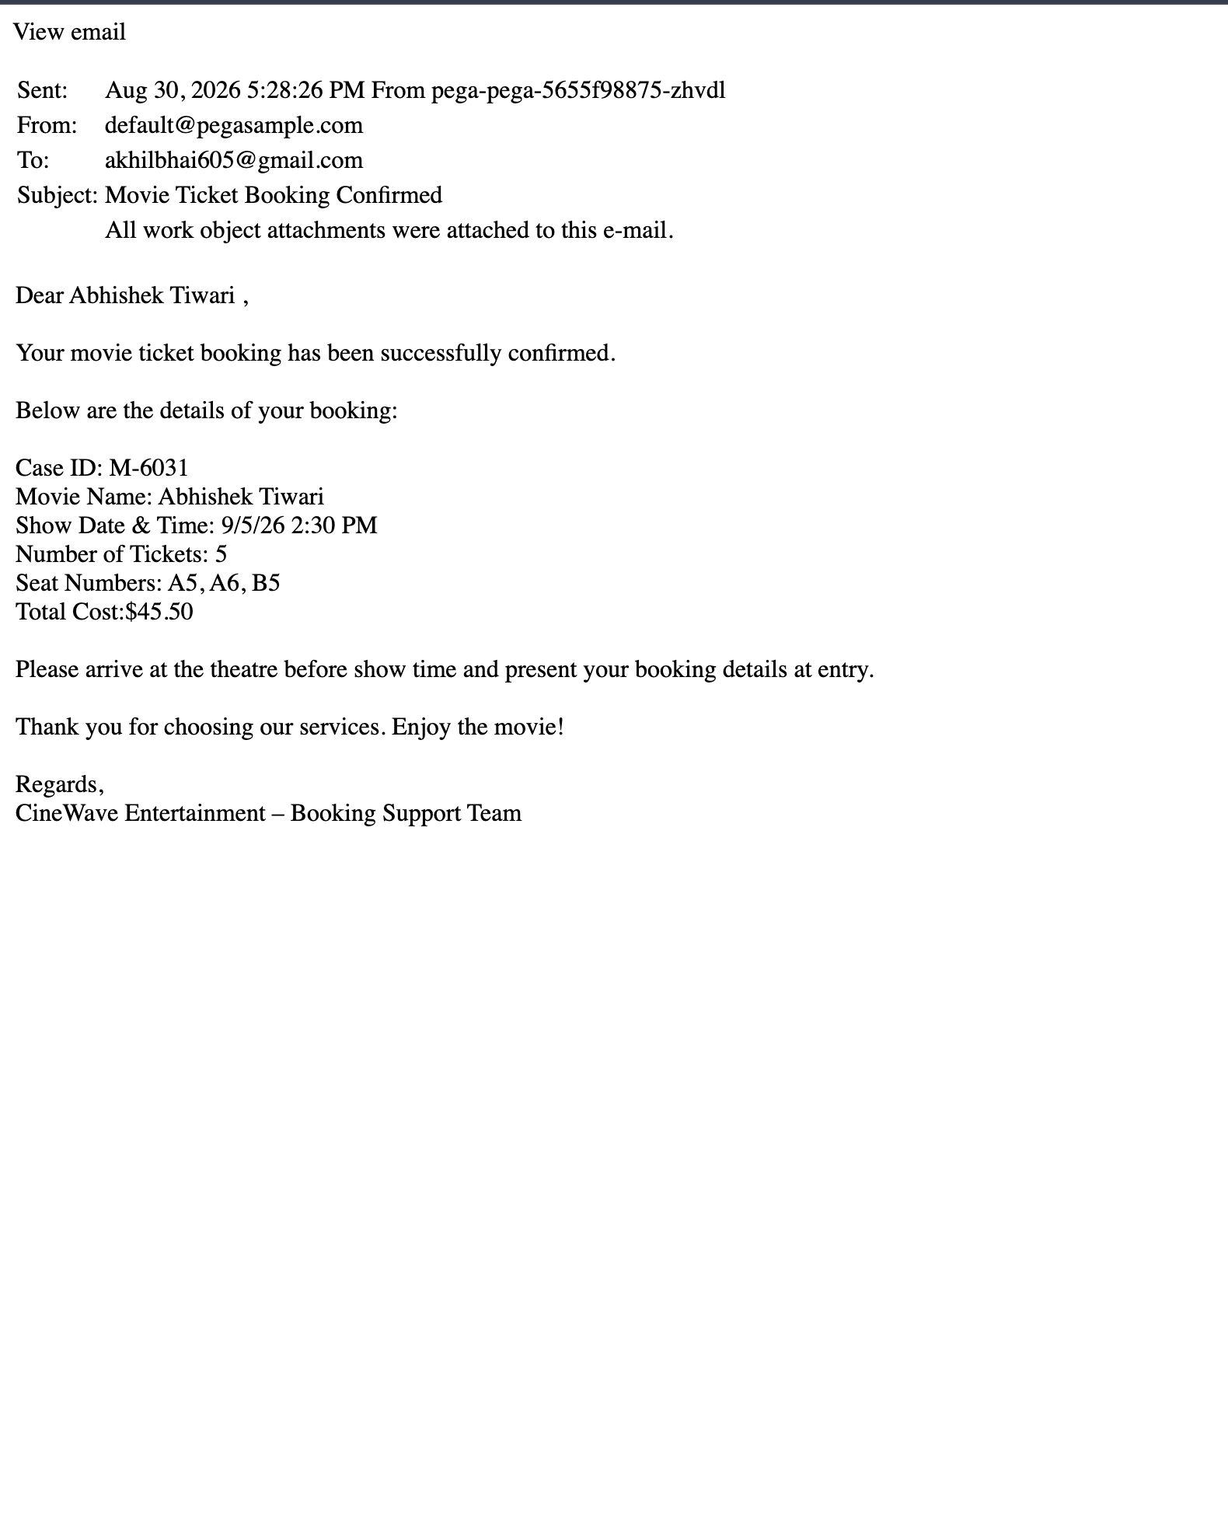

What I built for this (1–2 lines in your own words):
Configured a confirmation correspondence step intended to send booking details when the case reaches the Resolved stage.

US-009 — Define Booking SLA
What is expected:
SLA configured on the case type. Goal: 1 day. Deadline: 2 days. Priority increases on breach.
Screenshot — paste your screenshot below this line:
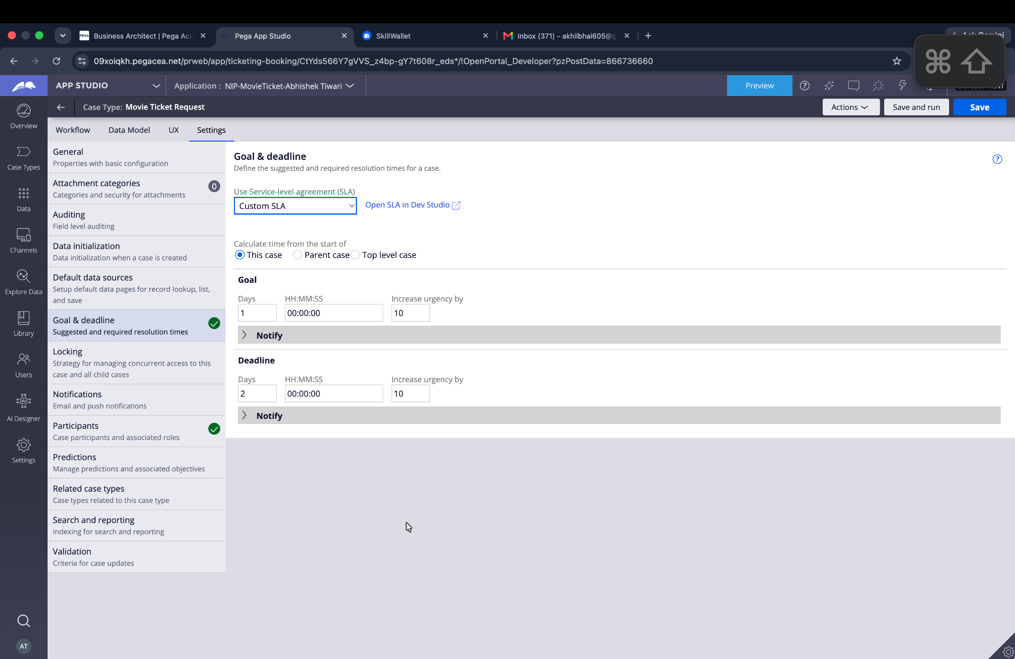
Screenshot 2026-08-30 at 16.26.15

What I built for this (1–2 lines in your own words):
Configured a Custom SLA on the case type with a 1-day goal and a 2-day deadline, with urgency increases on breach.

US-010 — Route by Show Type
What is expected:
Routing rule or Decision Table routes to PremiumShowQueue or StandardShowQueue based on Show Type property.
Screenshot — paste your screenshot below this line:
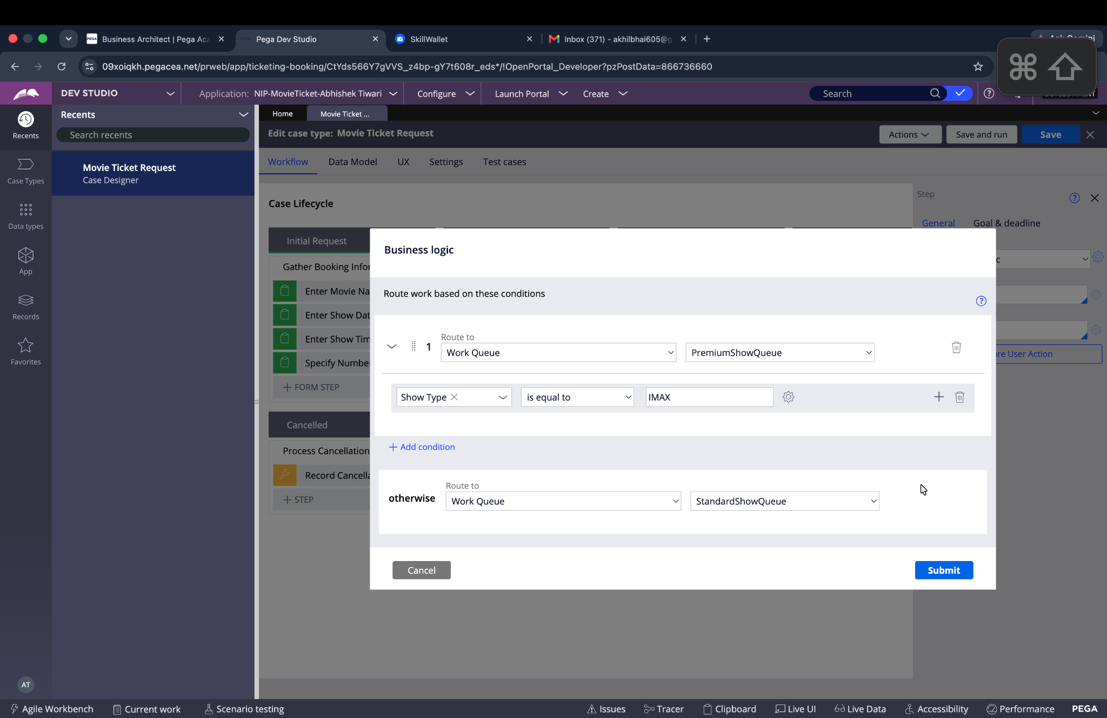
Screenshot 2026-08-30 at 16.36.24

What I built for this (1–2 lines in your own words):
Configured Business Logic routing so IMAX requests go to PremiumShowQueue and all other show types go to StandardShowQueue.

Section 3 — About Your Application
These answers are checked against your screenshots. Write exactly what is in your application.

Q1. List your stages in the order they appear in your case lifecycle.
Stage names in order, separated by commas.
Initial Request, Availability, Approval, Booking Execution, Resolved

Q2. Name the data object(s) you created and the properties inside them.
Data object name and its properties.
Movie: Movie Name, Genre. Show: Show Date, Show Time, Seat Capacity. These reusable objects are associated with the Movie Ticket Request case.

Q3. What is the exact name and type of the rule you used to calculate Total Cost?
Provide:
• Rule Name
• Rule Type
• Properties used in the calculation
• Formula used
Rule Name: CalculateTotalCost
Rule Type: Declare Expression
Properties used: Ticket Price, Number of Tickets
Formula: Ticket Price × Number of Tickets

Section 4 — Your Understanding
Short, honest and specific answers score well.

Q4. What did Blueprint generate for you, and what did you add or change yourself afterwards?
Be specific about what was already there and what you built or modified on top.
Blueprint generated the initial case lifecycle, stages, steps, fields, personas, and the overall ticket-booking scaffold. I then configured the booking-specific calculations, approval behavior, booking execution values, correspondence, SLA, work-queue routing, and a dedicated operator.

Q5. Was there anything Blueprint created that you had to correct or configure further? Describe one example.
A real example from your own work.
One correction was the operator setup and routing configuration. I had to create the final operator with my full name and copy a valid organizational unit (UPlus / Consumer / Fraud) so the operator could be saved. I also refined the routing configuration in Dev Studio.

Q6. Explain your case flow from creation to resolution, in order.
What happens first, who does what, when the case closes.
The customer creates a Movie Ticket Request and enters movie, show date, show time, and ticket quantity. Availability is checked and booking cost is calculated. The request then reaches Approval, where the booking status is confirmed. Confirmed requests move to Booking Execution, where ticket ID and seat numbers are maintained. Finally, the case is finalized and reaches Resolved, with the confirmation correspondence step configured for completion.

Q7. Pick two design choices you made in your application and explain why you made them.
For each design choice, provide:
• What you implemented
• Why you chose that approach
• What benefit it provides to the application
1) I used a dedicated Availability stage because seat availability is a separate business decision and should be checked before final booking. This keeps the flow easy to follow.
2) I used show-type work-queue routing because premium/IMAX work can be handled separately from standard bookings, making assignment more targeted.

Q8. What was the hardest part, and how exactly did you fix it?
Specific and honest. A real challenge scores much better than a generic answer.
The hardest part was getting the generated workflow and fields into a state that worked correctly with my custom operator. I resolved it by creating the operator, assigning a valid organizational hierarchy, testing the case end to end, and correcting the booking execution/routing configuration in Dev Studio.

Q9. If the approval step was only needed when Total Cost is above a certain amount, what would you change in your application?
Explain what you would change and where. You do not need to build this.
I would add a conditional routing/approval rule before the Approval stage: when Total Cost is greater than the chosen threshold, route to the Approval step; otherwise skip Approval and continue directly to Booking Execution. The condition would be based on the calculated Total Cost field.

Q10. List three exact rule names from your application that you personally created or modified.
Include the rule name and rule type for each one (for example: CalculateTotalCost - Declare Expression).
CalculateTotalCost — Declare Expression; ProcessConfirmedBooking — Data Transform; BookingExecution_Flow — Flow.
Q11. List all personas used in your application.
List the persona names exactly as they appear in your application.
Booking Agent, Customer, Users
Q12. List all work queues used in your application and explain when each one is used.
For each work queue, provide its exact name and the condition or type of work routed to it.
PremiumShowQueue — used for IMAX/premium or special screenings. StandardShowQueue — used for all other show types. BookingAgentQueue — used for the booking approval/work assignment shown in the case flow.
Before You Submit — Check These
Read through once before uploading.
1. Section 1 filled in. Application named as NIP-[Project]-[YourName]. Names match the actual application.
2. New Operator created in Pega with my full name. I logged in as that operator for all screenshots.
3. Only my chosen project section remains — the other project section is deleted.
4. All 10 user story screenshots are pasted and follow the operator, running-case, application, and rule-name evidence requirements.
5. Every question in Sections 3 and 4, including Q10, Q11, and Q12, is answered in my own words.
6. This file is named using the required format: ProjectName_FirstName_LastName.docx (for example, VehicleService_Ravi_Kumar.docx or MovieTicket_Ravi_Kumar.docx) and uploaded as required.

